Class Registration on VIC
Step 1: Login to VIC
Log in to your NSULA student account at vic.nsula.edu. Once logged in, click the View All Cards icon located in the upper-right corner of the screen to display all available cards.

Step 2: Find Registration Card
On the left side of the page, click the Find Cards search bar and type Registration. From the results list, select NSU Student Registration.
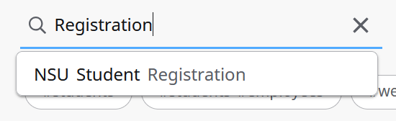
Step 3: Select Register for Classes
Within the NSU Student Registration card, click the Register for Classes button to begin the registration process.
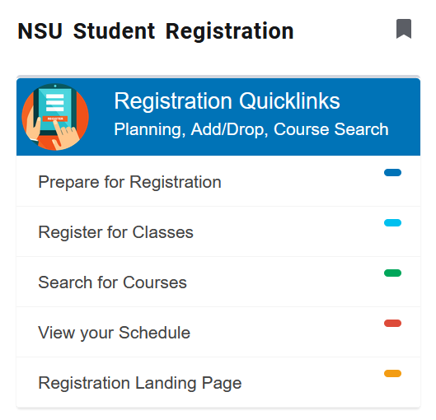

Step 4: Select Academic Term
Select the appropriate academic term from the dropdown menu and click Continue. If your academic status requires an Alternate PIN, you will be prompted to enter it before proceeding.
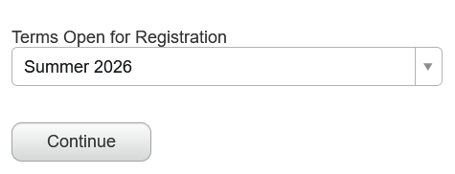
Step 5: Find Classes or Enter CRNS
On the left side of the page, select either Find Classes or Enter CRNs to add courses to your schedule.
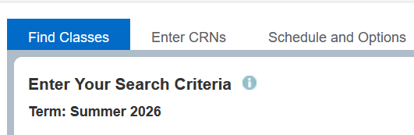
Using Find Classes: Use the Subject, Course Number, or Keyword fields to search for courses that match your criteria, then click Search.
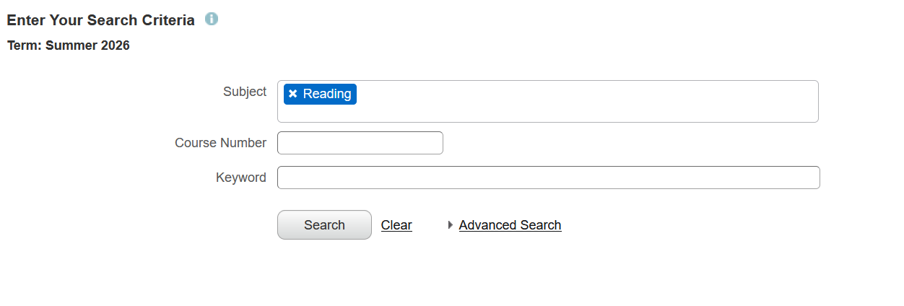
On the right side of the page, click the Add button next to the course you would like to register for.

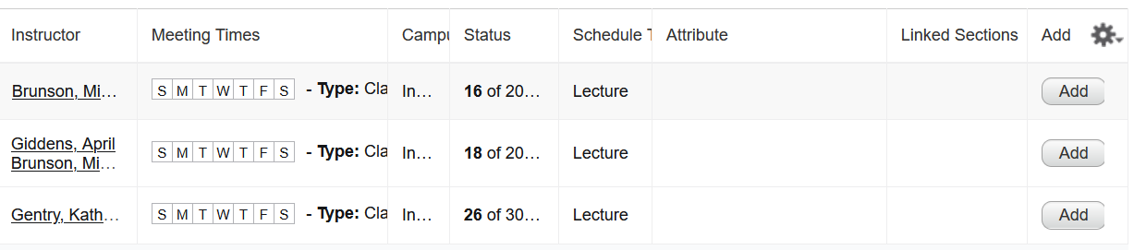
All selected courses will appear in the Summary panel located in the bottom-right corner of the page. Once all desired courses have been added, click Submit to complete your registration.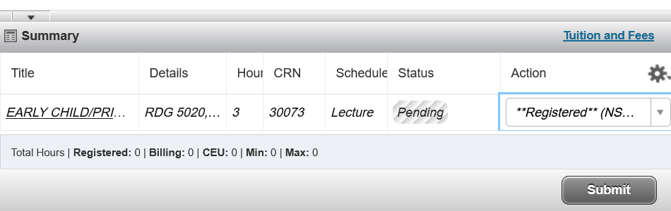
Using CRNs: Enter the Course Reference Number (CRN) in the CRN field. To add additional courses, click + Add Another CRN.
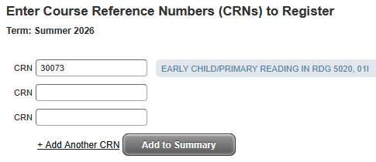
After entering all CRNs, click Add to Summary. Your selected courses will appear in the Summary panel located in the bottom-right corner of the page.
Once all courses have been added, click Submit to complete your registration.

Step 6: Drop a Course
To drop a course, locate the course within the Summary panel and click the dropdown menu to the right of the course. Select Remove.
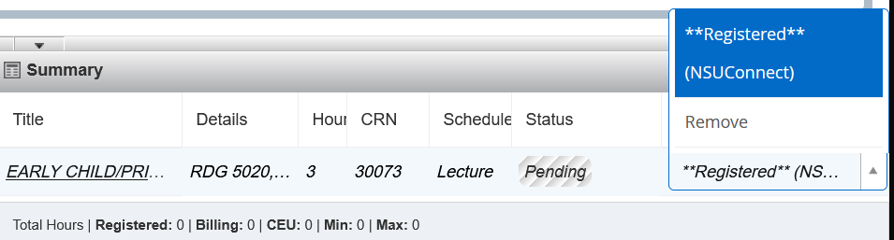
Click Submit to finalize the change and remove the course from your registration schedule.

